**ASSIGNMENT:MYSQL**

**BATCH:3-DATA SCIENCE&MACHINE LEARNING**

**NAME: NANDINI PANJWANI**

**Problem Scenario**

The Indian Government wants to develop a **Library Management System (LMS)** to store information of the members, books, status of books issue, book availability and suppliers details

**List of Tables:**

Table #1: LMS_MEMBERS

Table #2: LMS_SUPPLIERS_DETAILS

Table #3: LMS_FINE_DETAILS

Table #4: LMS_BOOK_DETAILS

Table #5: LMS_BOOK_ISSUE

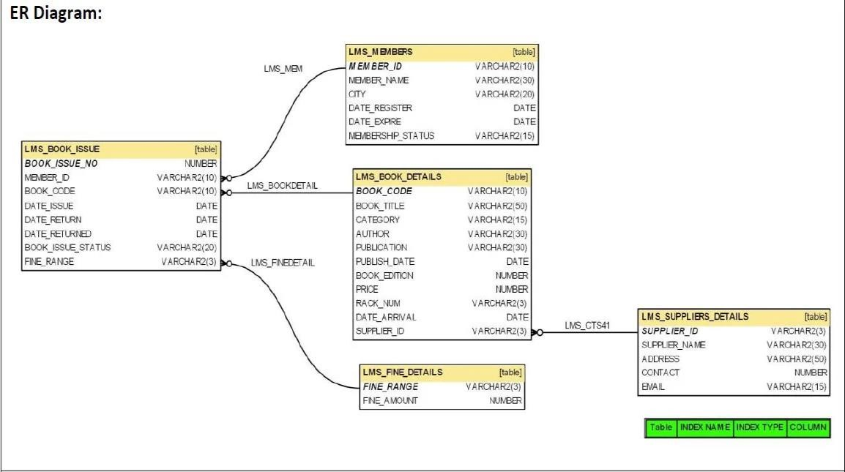

**Problem # 1:**

Write a query to display the member id, member name, city and membership status who are all having life time membership. Hint: Life time membership status is “Permanent”.

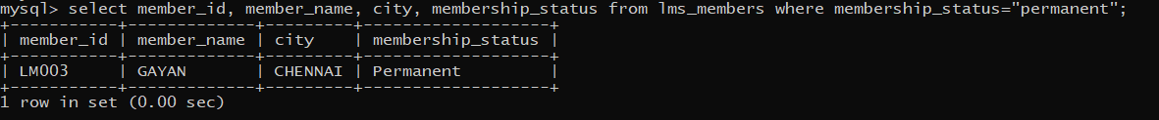

**Problem # 2:**

Write a query to display the member id, member name who have not returned the books. Hint: Book return status is book_issue_status ='Y' or 'N'.

**Problem # 3:**

Write a query to display the member id, member name who have taken the book with book code 'BL000002'. 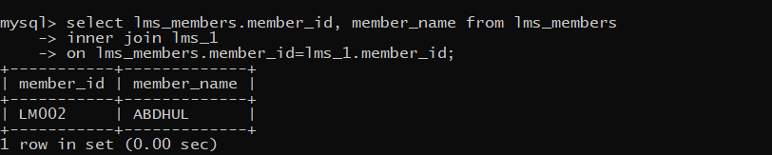

**Problem # 4:**

Write a query to display the book code, book title and author of the books whose author name begins with 'P'.

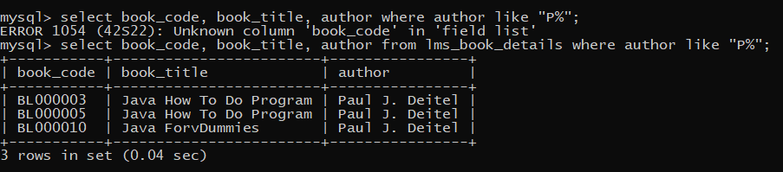

**Problem # 5:**

Write a query to display the total number of Java books available in library with alias name ‘NO_OF_BOOKS’.

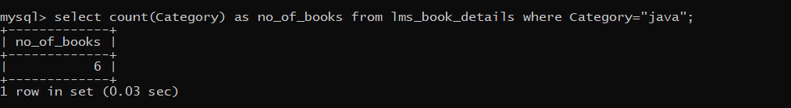

**Problem # 6:**

Write a query to list the category and number of books in each category with alias name ‘NO_OF_BOOKS’.

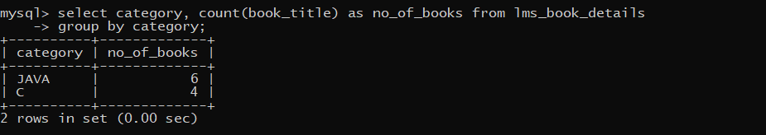

**Problem # 7:**

Write a query to display the number of books published by "Prentice Hall” with the alias name “NO_OF_BOOKS”.

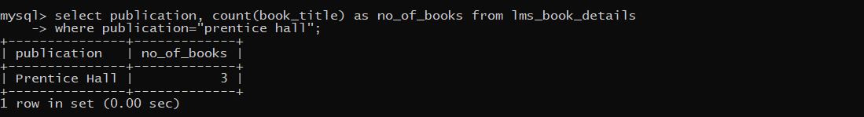

**Problem # 8:**

Write a query to display the book code, book title of the books which are issued on the date "1st April 2012". 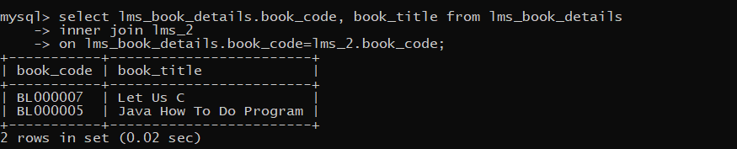

**Problem # 9:**

Write a query to display the member id, member name, date of registration and expiry date of the members whose membership expiry date is before APR 2013.

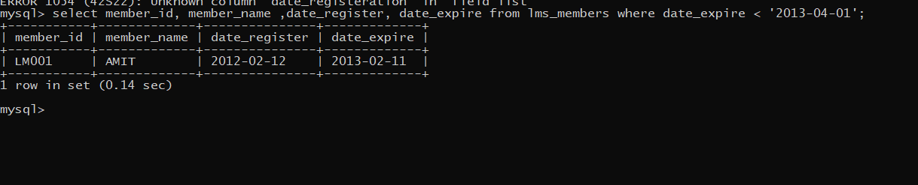

**Problem # 10:**

write a query to display the member id, member name, date of registration, membership status of the members who registered before "March 2012" and membership status is "Temporary"

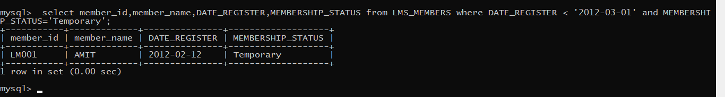

**Problem #11:**

Write a query to display the member id, member name who’s City is CHENNAI or DELHI. Hint: Display the member name in title case with alias name 'Name'.

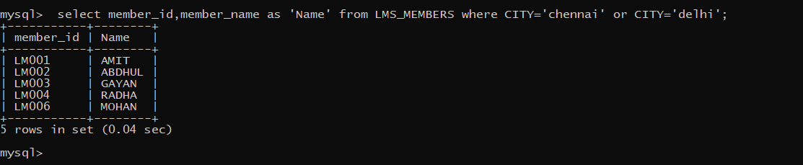

**Problem #12:**

Write a query to concatenate book title, author and display in the following format.

Book_Title_is_written_by_Author

Example: Let Us C_is_written_by_Yashavant Kanetkar

Hint: display unique books. Use “BOOK_WRITTEN_BY” as alias name.

**Problem #13:**

Write a query to display the average price of books which is belonging to ‘JAVA’ category with alias name “AVERAGEPRICE”.

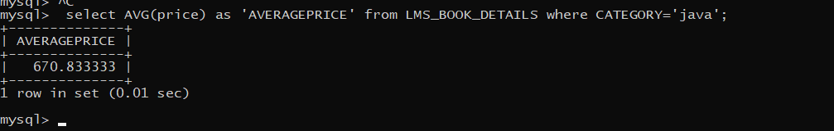

**Problem #14:**

Write a query to display the supplier id, supplier name and email of the suppliers who are all having gmail account.

